MARTIN LUTHER – GERMAN – BORN IN SAXONY IN 1483

Studied law Caught in a Swears to devote
storm life to God – so
becomes a monk Dad angry
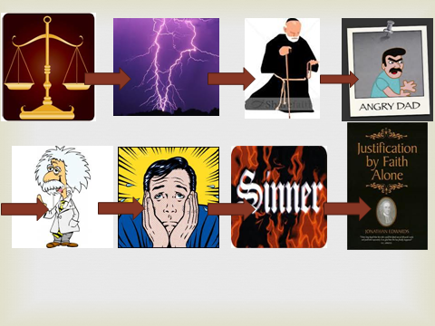
Became Prof of Worried he was Disagreed with PAINS.
Theology at a sinner & what Believed in Justification by
Wittenberg might happen when Faith Alone i.e., only faith
he died. needed to get into heaven –
not faith plus good
works or buying indulgences

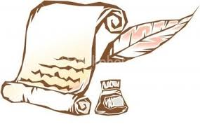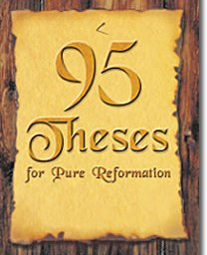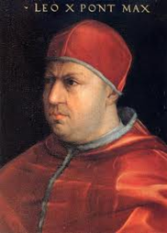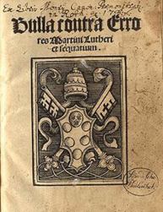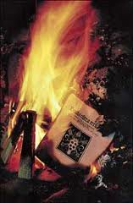
Wrote letter to Nailed to wall Pope not pleased Pope sends Papal Luther refuses &
Bishop of Wittenberg His representative Bull ordering burns Papal Bull
complaining Castle Church - is sent to debate Luther to recant in in public
re PAINS - copies made on Luther’s ideas 60 days or be
letter ignored new printing at Liepzig excommunicated
press - spread

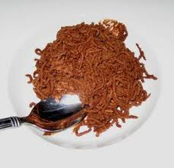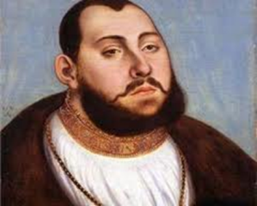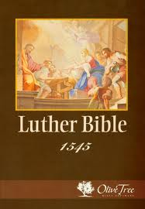
Called to Diet of Frederick the Wise Here, he translates Finally safe to come out of
Worms – asked to kidnaps him and keeps New Testament hiding.Took charge of religious
Recant – refuses – him safe at Wartburg into German changes in Germany – His
Declared an outlaw Castle followers grew – called
Lutherans – other Princes and
The Diet of Worms states adopted his ideas -
was a meeting of wife = Catherine von Bora
German Princes, Charles V 6 children - continues to Luther write pamphlet

